**DEVELOPMENT OF PORTABLE EMI/EMC, INDUCTION MEASUREMENT**

**INSTRUMENTS.**

**Introduction:**

The goal of the Portable EMI/EMC Meter project is to provide an electromagnetic interference (EMI) and electromagnetic compatibility (EMC) measurement tool that is lightweight, portable, and easy to use. To evaluate adherence to EMC standards, this meter is intended to identify and examine electromagnetic interference (EMI) emissions from a range of electronic equipment, machinery, and infrastructure. The gadget has powerful signal processing algorithms for precise EMI detection and wireless connectivity for distant data transfer.

## Key Features:

* Compact and portable design.
* Wireless data transmission (LoRa wan).
* Advanced signal processing for EMI detection.
* Rugged 3D-modeled outer structure for industrial applications.

# Objective

The main objective of the project is to create a portable electromagnetic radiation and current meter (EMI/EMC meter) that can be used to measure and analyze electromagnetic emissions in a variety of settings, such as industrial and urban systems. This technology provides a lightweight, user-friendly, and affordable substitute for the heavy, bulky, conventional EMI/EMC meters, thereby addressing their shortcomings.

## Design Overview

The goal of the EMI/EMC meter's design process is to strike a compromise between portability, accuracy, and user-friendliness. The main design choices—such as the choice of essential parts, the incorporation of 3D modeling for the external structure, and the integration of signal processing methods—are described in this section.

## System Architecture:

* **Probes/Sensors**: Loop and dipole antennas for detecting EMI across different frequency ranges, along with Hall-effect sensors for magnetic field interference.
* **Signal Conditioning**: Use of low-noise amplifiers (LNAs) and analog filters (low-pass, high-pass) to amplify and clean up the incoming EMI signals.
* **ADC (Analog-to-Digital Converter)**: A high-resolution ADC to digitize the conditioned signals.
* **Digital Signal Processing (DSP)**: A microcontroller/DSP for filtering, analysing, and detecting EMI signals.
* **Wireless Module**: Raspberry Pi Pico Connected with LoRa Module for Data transmission without using internet
* **User Interface**: LCD display for real-time EMI level visualization and LED indicators for alert

# 3D Model Fabrication

Using cutting-edge 3D modeling tools, the meter's exterior construction was created to guarantee a strong, lightweight, and ergonomic shell. This design shields delicate internal components from the severe environments that are frequently encountered in industrial applications, while also improving portability.

## 3D Design Process

All internal components were modeled into the enclosure in a small form factor. The materials used in the production process guarantee durability while keeping a lightweight profile for handling comfort.

## Benefits of 3D Fabrication

* Lightweight and portable.
* Ergonomic design for user comfort.
* Rugged structure for durability in industrial environments.
* 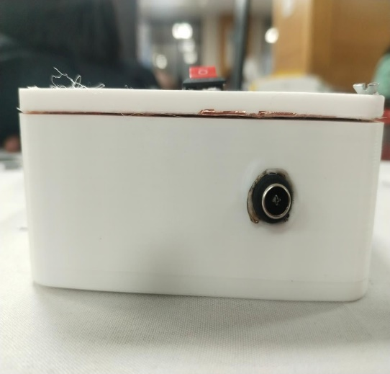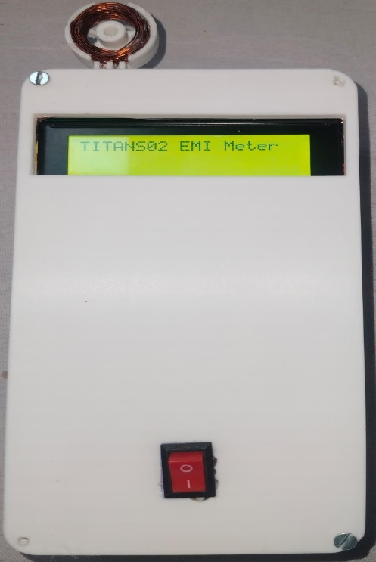Customizable for future iterations or additional features.

# Hardware Components

This section provides a detailed breakdown of the components used in the EMI/EMC meter:

## Antennas and Sensors

* **Loop Probes**: For low-frequency EMI detection.
* **Dipole probes**: For high-frequency EMI detection.
* **Hall-Effect Sensors**: For detecting magnetic field interference.

## Amplifiers and Filters

* **Low Noise Amplifiers (LNAs)**: To boost weak EMI signals without adding significant noise.
* **Low-Pass and High-Pass Filters**: For cleaning the signal by removing unwanted noise and hum before digitization.

## Analog-to-Digital Converter (ADC)

* A high-resolution ADC (16-24 bits) with a sampling rate capable of handling EMI signals in the MHz range.

## Microcontroller/DSP

* **Raspberry Pico with LoRa**: Responsible for handling signal processing and wireless communication.
* **DSP Algorithms**: For real-time filtering, frequency analysis, and threshold-based detection.

# EMI SHIELDING

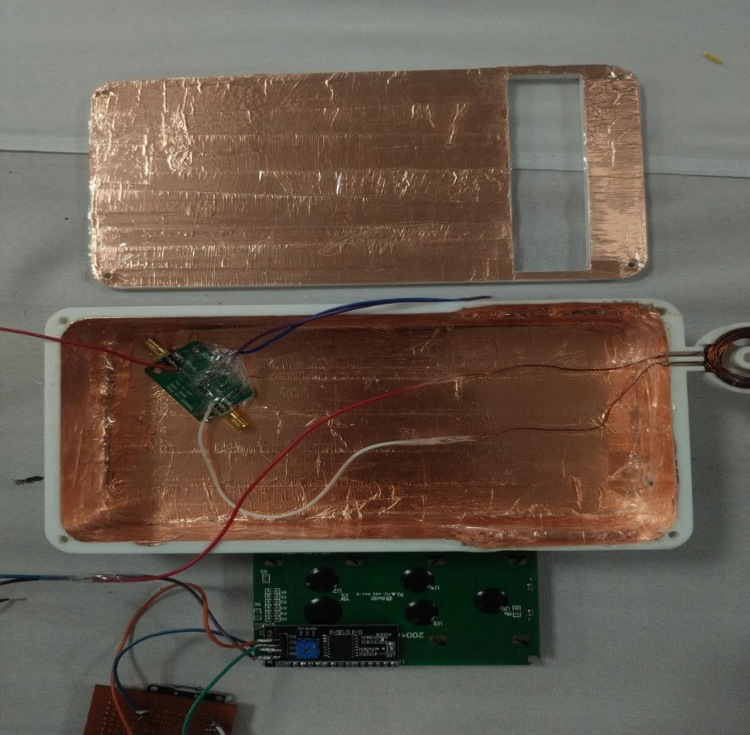

# Signal Processing

The signal processing stage involves real-time filtering and analysis of incoming EMI signals to accurately detect and quantify interference.

## Digital Filtering

* **Band-Pass Filters**: Applied to focus on specific EMI frequency bands, ensuring accurate detection across different environments.
* **Time-Domain Analysis**: Detects transient EMI spikes and logs them for analysis.

## Threshold Detection

The system continuously monitors EMI levels and compares them to pre-set thresholds. If an

irregularity in EMI is detected, an alert is triggered, and data is transmitted wirelessly for further analysis.

# Wireless Communication

The meter is equipped with wireless communication capabilities to allow remote monitoring and data logging. The **Raspberry Pico** controller embedded with LoRa for wireless communication

## Real-Time Data Transmission

* The system transmits real-time EMI readings to connected devices (smartphones, tablets, or PCs).
* Data can be logged remotely for future analysis or compliance reporting.

## Alerts and Notifications

* If any irregularity in EMI is detected, an alert is automatically sent to the connected devices.
* Visual alerts are also provided via LED indicators on the device.

# User Interface (UI)

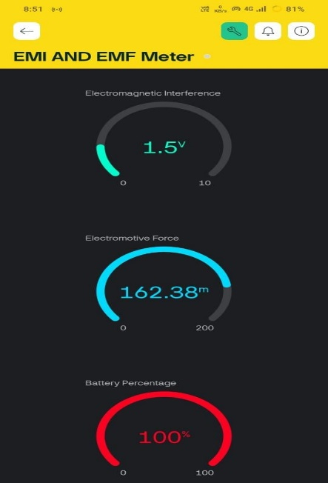The EMI/EMC meter features a simple, intuitive user interface to ensure ease of use even in industrial environments.

## LCD Display

* Real-time display of EMI levels across different frequency bands.
* Information on battery status and wireless connectivity.

## LED Indicators

* Visual alerts for threshold breaches or irregular EMI readings.

## Buttons/Touch Controls

* Allows users to switch between frequency bands and control basic operations of the meter.

# Power Management

The device is powered by a **rechargeable Li-ion battery** designed to provide long-lasting operation in field environments.

## Power Regulation

* Voltage regulation ensures stable power delivery to sensitive components.

## Battery Life

* The system is optimized for efficient power consumption, allowing extended usage in the field without frequent recharges.

# Testing and Calibration:

This section explains the procedures followed to test and calibrate the EMI/EMC meter.

## Signal Accuracy Testing

* The meter was tested across different frequency bands to ensure accuracy in measuring EMI levels.

## Calibration Methods

* Standard calibration techniques were used to ensure the meter meets industry EMI/EMC standards.

# Applications:

The portable EMI/EMC meter has a wide range of applications across industries.

## Industrial Applications

* **Metro Systems**: Detect EMI interference from high-voltage power supplies near electronic systems.
* **Manufacturing**: Monitor EMI emissions from machinery and electrical systems.
* **Telecommunications**: Ensure compliance with EMI/EMC standards in network infrastructure.

## Compliance and Safety

* Helps industries maintain compliance with EMI/EMC regulations to ensure the safety and reliability of electronic systems.